CRICKSTATS – SALESFORCE CAPSTONE PROJECT
PHASE 2 – REQUIREMENT ANALYSIS
CRICKET PLAYER PERFORMANCE TRACKING APPLICATION
Information | Details
Project Title | CRICKET PLAYER PERFORMANCE TRACKING APPLICATION  CRICKSTATS
Project Domain | Cloud Computing / Salesforce Administration
Platform | Salesforce Lightning Developer Edition
Team Leader | Saravanan S - (Reg. No. 24134031802521044)
Member 2 | SRIVARSHAN S- (Reg. No. 24134031802521048)
Member 3 | Tamilselvan S- (Reg. No. 24134031802521051)
Member 4 | Karthi Karthi- (Reg. No. 24134031802521020)
Member 5 | Barathiraja R- (Reg. No. 24134031802521013)
Institution | PS PT MGR GOVERNMENT ARTS & SCIENCE COLLEGE, SIRKALI, PUTHUR-609108 (College Code: ANM403)
Submission Portal | SkillWallet / Naan Mudhalvan

1. Customer Journey Map
- Login – User authenticates into Salesforce.
- Enter Player Data – Admin registers player profiles and demographic details.
- Record Match Performance – Logs match-by-match scores, bowling figures and fielding statistics.
- Generate Reports – System summarizes aggregated metrics across teams and tournaments.
- Analyze Results – Analysts review statistical performance through tables and charts.
- Decision Making – Coaches and management use data to support team-lineup decisions.

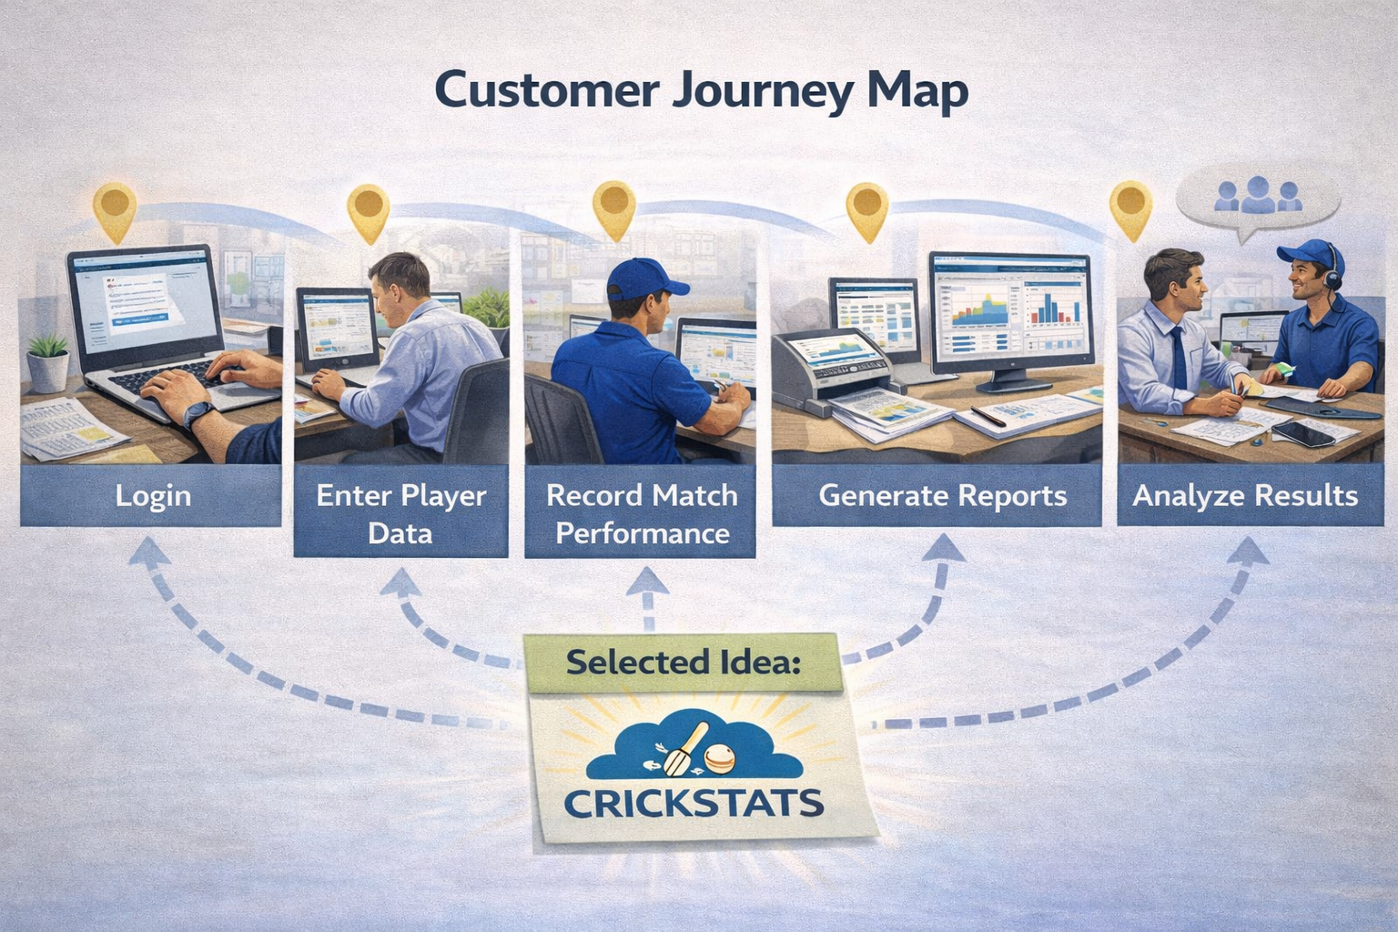

2. Functional Requirements
FR No | Requirement
FR-1 | Player Registration
FR-2 | Match Performance Entry
FR-3 | Dashboard Generation
FR-4 | Report Creation
FR-5 | Flow Automation

3. Non-Functional Requirements
NFR | Requirement
NFR-1 | Usability – simple interface, clear navigation, easy-to-read dashboards, minimal learning curve.
NFR-2 | Security – role-based access, secure authentication, encrypted storage and backups.
NFR-3 | Reliability – no data loss, backups, error handling and system stability.
NFR-4 | Performance – fast page loading, quick reports, smooth dashboards; 100+ player report target 2–3 seconds.
NFR-5 | Availability – 24/7 cloud availability, minimal downtime and disaster recovery.
NFR-6 | Scalability – growing datasets, more teams/leagues, expanded storage and maintained performance.

4. Data Flow Diagram
User → Salesforce UI → Player Object → Match Performance → Reports → Dashboard

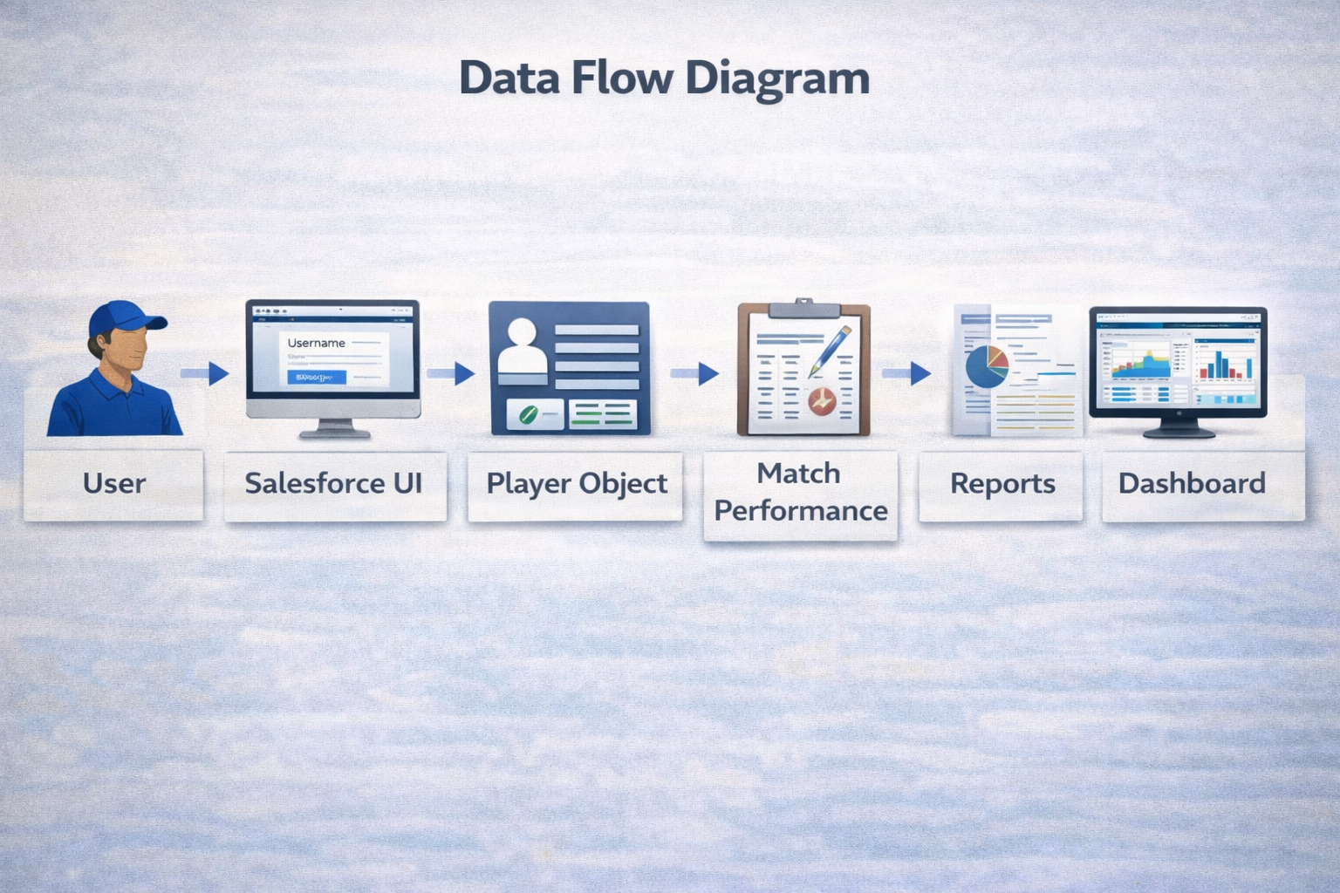

5. Technology Stack
Layer | Technology
Frontend | Salesforce Lightning
Analytics | Reports & Dashboards
Automation | Salesforce Flows
Backend | Salesforce Objects
Database | Salesforce Cloud

6. Phase Conclusion
The requirement phase defines the user journey, functional and non-functional requirements, data flow and technology stack for CRICKSTATS.

